Lab 9 Summary

Irvin, Mitchell

Section 7441

4/15/16

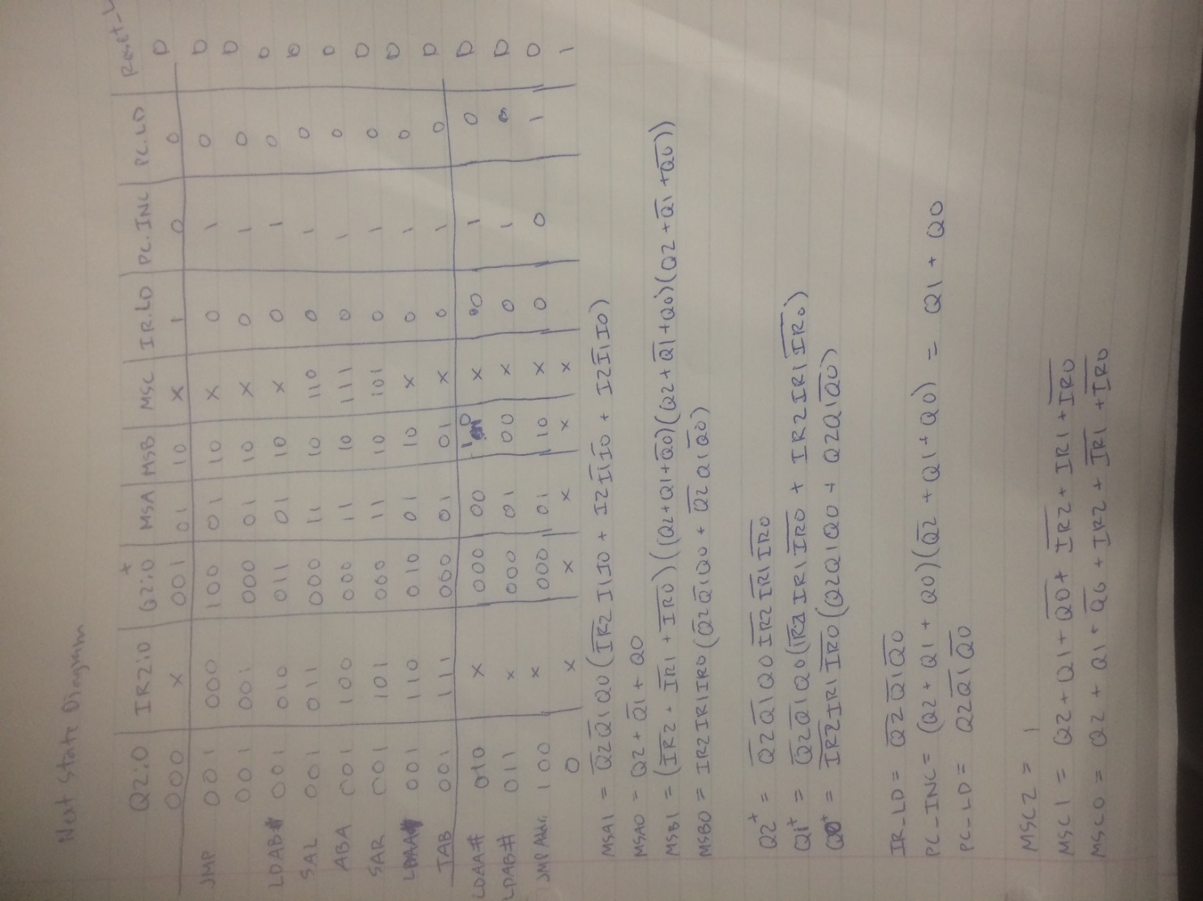

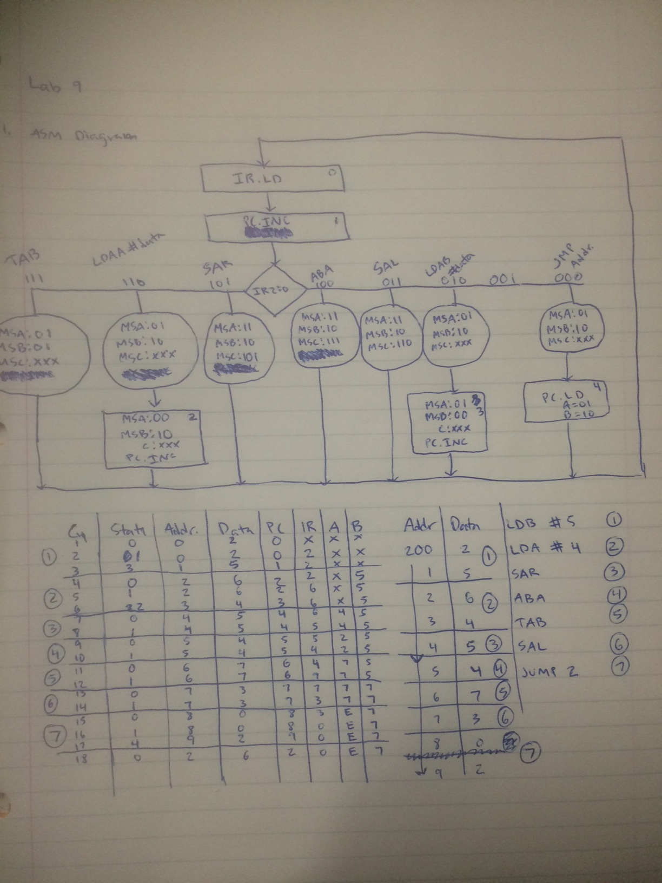

BDF files

Lab 9 bdf

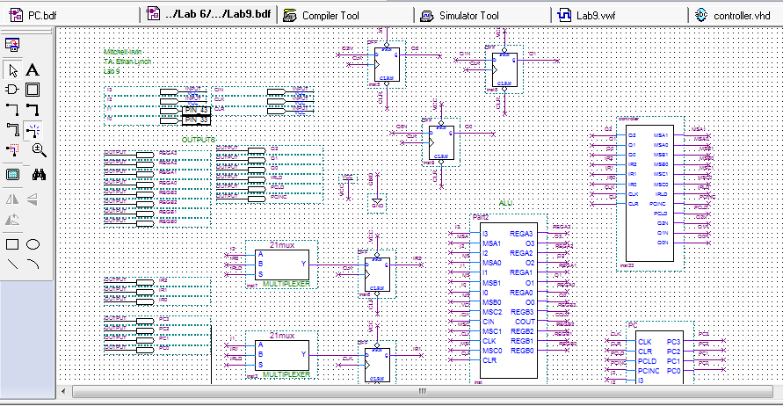

PC bdf

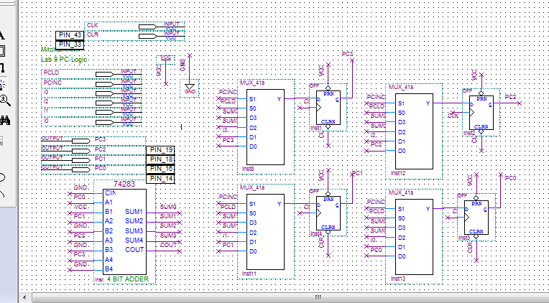

library ieee;

use ieee.std_logic_1164.all;

entity controller is port (

Q2, Q1, Q0, IR2, IR1, IR0, CLK, CLR: in bit;

MSA1, MSA0, MSB1, MSB0, MSC1, MSC0, IRLD, PCINC, PCLD: out bit;

Q2N, Q1N, Q0N: out bit

);

end controller;

architecture logic OF controller IS

begin

MSA1 <= ((not Q2) and (not Q1) and Q0) and (

((not IR2) and IR1 and IR0) or

(IR2 and (not IR1) and (not IR0)) or

(IR2 and (not IR1) and IR0) );

MSA0 <= (Q2 or (not Q1) or Q0);

MSB1 <= (Q2 or Q1 or (not Q0) or (not IR2) or (not IR1) or (not IR0)) and

(Q2 or (not Q1) or (not Q0));

MSB0 <= ( (IR2 and IR1 and IR0) and

((not Q2) and (not Q1) and Q0) );

MSC1 <= (Q2 or Q1 or (not Q0) or (not IR2) or IR1 or (not IR0));

MSC0 <= (Q2 or Q1 or (not Q0) or (not IR1) or IR2 or (not IR0));

IRLD <= ((not Q2) and (not Q1) and (not Q0));

PCINC <= (Q1 or Q0);

PCLD <= (Q2 and (not Q1) and (not Q0));

Q2N <= ((not Q2) and (not Q1) and Q0 and (not IR2) and (not IR1) and (not IR0));

Q1N <= ((not Q2) and (not Q1) and Q0) and (

((not IR2) and IR1 and (not IR0)) or

(IR2 and IR1 and (not IR0)) );

Q0N <= ((not Q2) and (not Q1) and (not Q0)) or

(((not Q2) and (not Q1) and Q0) and

((not IR2) and IR1 and (not IR0)));

end logic;

VWF Simulation of the correct instructions

